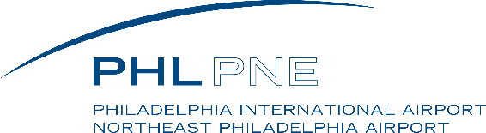
Allan F. Moore, Jr., PE, CM, Deputy Director of Aviation – Facilities, City of Philadelphia Division of Aviation. Allan Moore is the Deputy Director of Aviation for the City of Philadelphia Division of Aviation, which owns and operates Philadelphia International Airport and Northeast Philadelphia Airport. He oversees the Facilities Maintenance team within the airport’s Operations department.

Mr. Moore is responsible for the overall maintenance of the airport’s expansive facility, including all landside, terminal and airfield areas. He directs an extensive program aimed at delivering efficient operation and works closely with airport stakeholders. Mr. Moore has spent almost his entire career at the City of Philadelphia’s Airports. He has held leadership roles in both the Facilities Maintenance and Capital Development/Engineering groups. His background is in the design and construction management of large-scale maintenance, renovation, and expansion projects at the two airports.

Mr. Moore is a registered Professional Engineer in the state of Pennsylvania and a Certified Member of AAAE.

