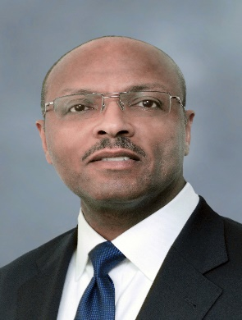

Charles R. Everett, Jr., C.M., CMC®

Mr. Everett serves as the Deputy Director, Aviation and General Manager of John F. Kennedy International Airport (JFK) for the Port Authority of New York and New Jersey. In this dual role he provides oversight to an executive management team of 13 senior staff members and nearly 1,500 employees, who operate a five-airport system, including JFK, Newark-Liberty International, LaGuardia, New York Stewart International and Teterboro Airports. He assists in leading all aspects of airport operations, maintenance, commercial activities, redevelopment, financial services, safety, strategy, business performance and customer experience. He has served as the chief executive of three U.S. airports: Syracuse, New York, Allentown-Lehigh Valley, Pennsylvania, and New York-JFK. JFK is the most frequently used port of entry and departure for international flights in North America with 90 airlines, 155 non-stop destinations, and over 62 million annual passengers.

Mr. Everett was employed by various engineering, management consulting firms and municipal organizations involved with planning, operations and development of aviation and urban transportation infrastructure. He is also a retired officer of the U.S. Air Force Reserve with a military specialty in logistics plans and extensive experience in organizational leadership.

Mr. Everett is a Certified Member of the American Association of Airport Executives, a Certified Management Consultant by the Institute of Management Consultants USA, an Organization Development Certified Professional, Past President of the New York Aviation Management Association, and a former member of the Board of Directors of Airports Council International - North America.

Mr. Everett received a bachelor’s degree in Urban Studies, with a concentration in Transportation Planning, from the College of Arts & Sciences of the University of Pennsylvania. He is completing a Master of Business Administration degree in International Business from the University of Cumbria.

July 2021

